Day 7 :
creating rest api with in memory (array) for product
Get Method : get all product details in json format.
Search the product id
- Query param
URL?key=value
URL?key1=value1&key2=value2
URL?key1=value1&key2=value2&key3=value3
If client is normal form with get method. Because form with get method internally use query param technique.
- Path param
URL/value1
URL/value1/value2
Post method : store product data with product id must be unique

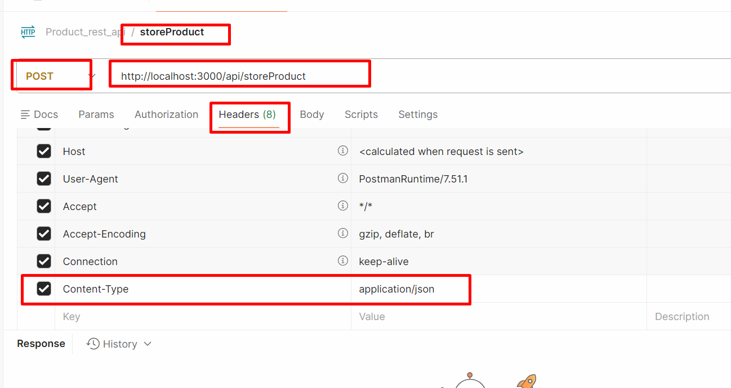
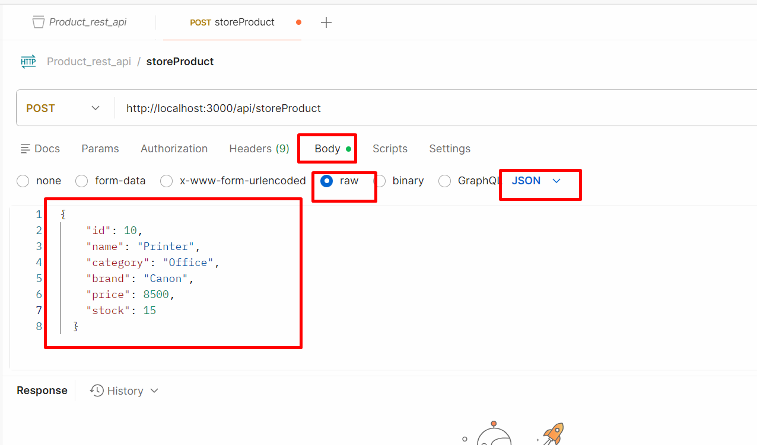

By default express js doesn’t extract data from post body data. We need to use middleware.

Put/Patch method : update product price

Put or patch method : it is use to update the existing resource with unique property.
Put is use to update complete existing object property.
Patch is use to update partially not all property.
Delete method: delete the product using pid

Using node js express module we can connect to database.
Mongo Db

To connect mongo db node js provided third party module
- mongodb : schema less(native driver)
- mongoose : schemas base. In collection contains that type of property with their data types.

mkdir product-api-with-mongodb
npm init
npm install express mongodb

Frontend Backend Database
Express JS with EJS Mongo db
Or MySQL
Or
File System

Express rest api in array
We are testing In file
Using postman client In database
Mongo db module Mongo db or mysql
React js
Angular framework
MERN Stack
Mongo Db Express Node js React JS

Mongoose : Mongoose is another third party module which use schema base concept. Which is base upon ODM (Object Data Modeling )(ORM). In Mongoose we can create schema. Schema provide the structure for collection ie collection name, field name (mandatory or optional) and data types with validation.

mkdir product-api-with-mongoose
npm init
npm install express mongoose

Trainer -
Tid:1,tname:”Raj”,”tech”:[“Java”,”Python”,”Reac JS”],

